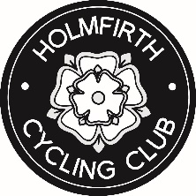

Parental Consent Form for Young Rider (under 16) joining Club Rides
RIDERS DETAILS
SURNAME
FIRST NAMES
DATE OF BIRTH
RIDERS MOBILE PHONE NUMBER
I.C.E. PHONE No. 1
NAME
I.C.E. PHONE No. 2
NAME
PARENT / LEGAL GUARDIAN DETAILS
FULL NAME
ADDRESS
TOWN
POSTCODE
PHONE No.
MOBILE No.
EMAIL ADDRESS
DECLARATION
I consent to my child attending Holmfirth Cycling Club organised rides on the public roads.
I understand that each rider is responsible for his/her own safety
I consent to the use of photographs that include my child by Holmfirth Cycling Club for promotional purposes.
Signed by parent/ legal guardian Date

